Joe Hilleary
5/8/2024
Spatial Statistics Spring 2024, Tufts University

Understanding Opposition to the MBTA Communities Act: A Tale of Two Cities

Introduction:
In 2021, the Massachusetts state legislature passed a law known as the MBTA Communities Act as part of an attempt to address the housing crisis. This law requires towns and cities served by the MBTA to “have at least one zoning district of reasonable size in which multi-family housing is permitted” [1]. Throughout the state, 177 communities fall under one of four categories defined by the law—Rapid Transit Communities, Commuter Rail Communities, Adjacent Communities, and Adjacent Small Towns. All of these communities had to submit an action plan to the state by January 2023, but the deadline for passing compliant zoning varies by category. The first group, Rapid Transit Communities, was required to pass compliant zoning by the end of 2023, with the others to follow over the next two years.
Despite requiring only zoning, and not development, there has already been vehement opposition from residents of the communities impacted by the legislation. In particular, two Rapid Transit communities saw organized opposition lead to public votes on whether or not to comply with the statute. In Brookline, this movement failed and compliant zoning was passed by the Town Meeting just before the end of year deadline. In Milton, the opposition succeeded on a ballot initiative, and the community is now in open violation of the statute and being sued by the state. This project explores the differences between these two towns in an attempt to understand what factors may have led to their divergent voting outcomes.
Opposition to changes in zoning, particularly those intended to encourage higher density development is often understood through the lens of NIBYism (Not in My Backyard). As the name suggests, NIMBYism is fundamentally related to spatial proximity. Thus, this investigation lent itself to the application of spatial analysis techniques.

Data:
To investigate the drivers of voting patterns in each town, I began by gathering data on the two communities. I acquired the precinct-level voting results from the two initiatives from the respective town websites. I then augmented this electoral data with socio-economic data from Social Explorer that was gathered at the census tract-level as part of the American Communities Survey. In particular, I was interested in demographic variables such as race and ethnicity as well as income and education based on the findings of Glick et al. as to who is most likely to oppose the development of new multi-family housing [2]. Following the work of Atkinson-Palombo and Kuby in “The geography of advance transit-oriented development in metropolitan Phoenix, Arizona, 2000–2007,” I also collected housing information, including the rate of renters vs homeowners [3].
I transformed several of these variables to be rates and pooled some variables which had been further broken down into categories, such as education, age, and commute time. Ultimately, I included 14 variables in my initial set: population density, percent female, percent over 65, percent White, percent Black, percent Asian, percent Latinx, percent with a bachelor’s degree or higher, median household income, vacancy rate, percent renter occupied households, median rent, percent public transit users, and percent that commute at least 30 minutes. Because the voting results were at the precinct level, I was forced to aggregate the census tract data. I did this by averaging the values for each tract that intersected a given precinct, excluding null or missing values, and assigning that mean to the precinct.
Shape files for the 2020 census tracts and the 2022 voting precincts along with point locations for MBTA rail stations came from the Massachusetts Bureau of Geographic Information (MassGIS) [4], [5], [6].

Analysis:
In designing my study, I drew on the existing literature of spatial analysis of NIMBYism. Following the work of Brown and Glanz in “Identifying potential NIMBY and YIMBY effects in general land use planning and zoning,” I began by examining spatial autocorrelation among the proportion of voters in each precinct that opposed the compliant zoning measures. While Brown and Glanz used Getis-Ord clustering, I calculated the Global Moran’s I for each town using a Queen’s weight matrix and then mapped the Local Moran’s I to see if there were clusters. There was some evidence for spatial autocorrelation in the case of Milton, which had a Global Moran’s I of 0.45—significantly greater than the expected value of -0.11. Brookline, on the other hand, had no such indication, given an insignificant difference between Global Moran’s I value of -0.12 and the expected value of -0.06. Neither turned up any clusters based on the LISA analysis.
Next, I plotted the locations of MBTA rapid transit stations in both towns on top of their voting results (See figure 1).
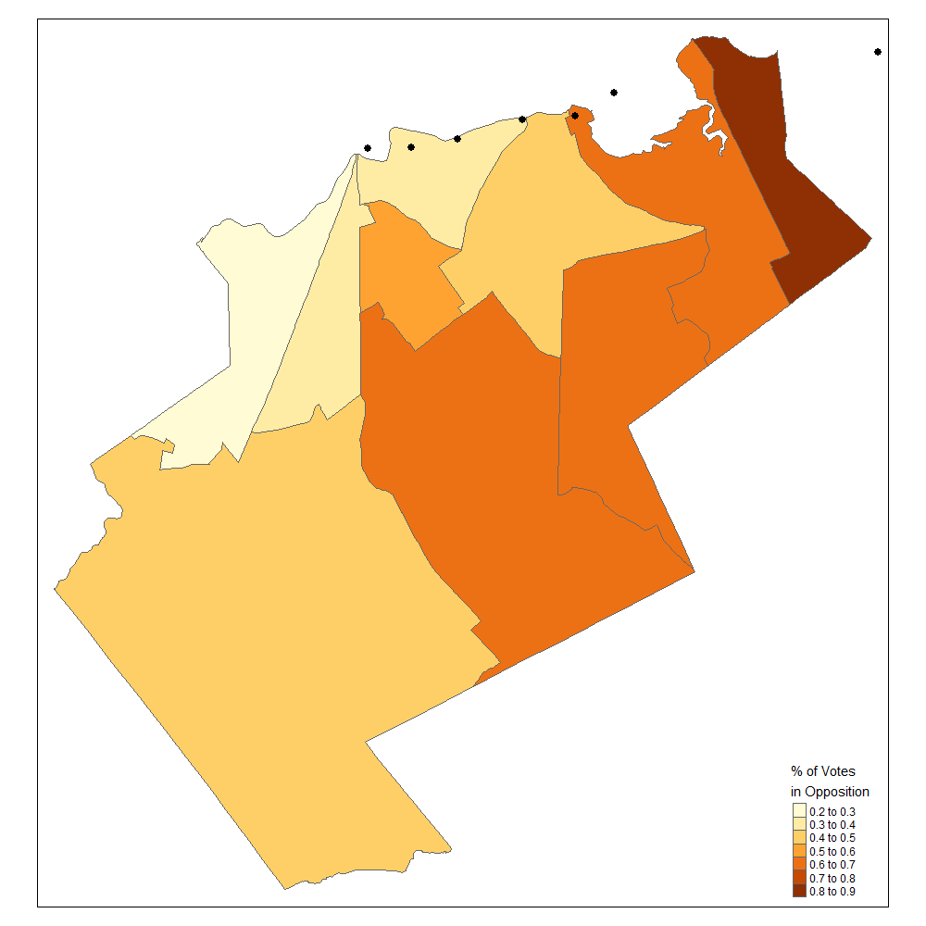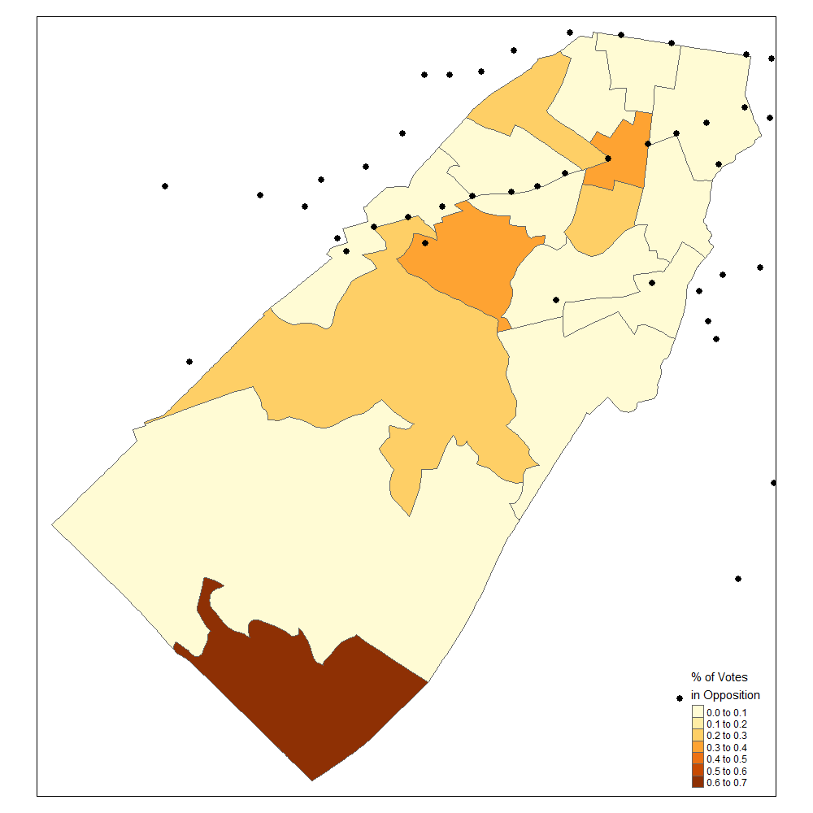
Figure 1. Milton (left) and Brookline (Right) Voting Results
Visual analysis again seemed to show that while a relationship might exist in Milton, it was not present in Brookline. I based this approach on Brown and Glanz use of distance to proposed site of opposition in their analysis of the spatial components of NIMBYism [7]. Unlike Brown and Glanz, I did not have point data for individual voters, so at best I could have calculated distance to station for precinct centroids, however, since there did not appear to be a consistent relationship, I opted to assume the commute times and public transit usage were sufficient proxies. In any case, the sites of interest were not actually the stations themselves, but the proposed zones, for which I did not have access to shapefiles for analysis.
Following this initial exploratory data analysis (EDA), I then looked at correlations between my proposed explanatory variables and the voting outcomes for each precinct. First, I generated parallel coordinate plots for each town (see figures 2 and 3), then I both calculated correlation coefficients and generated scatterplots for each variable.
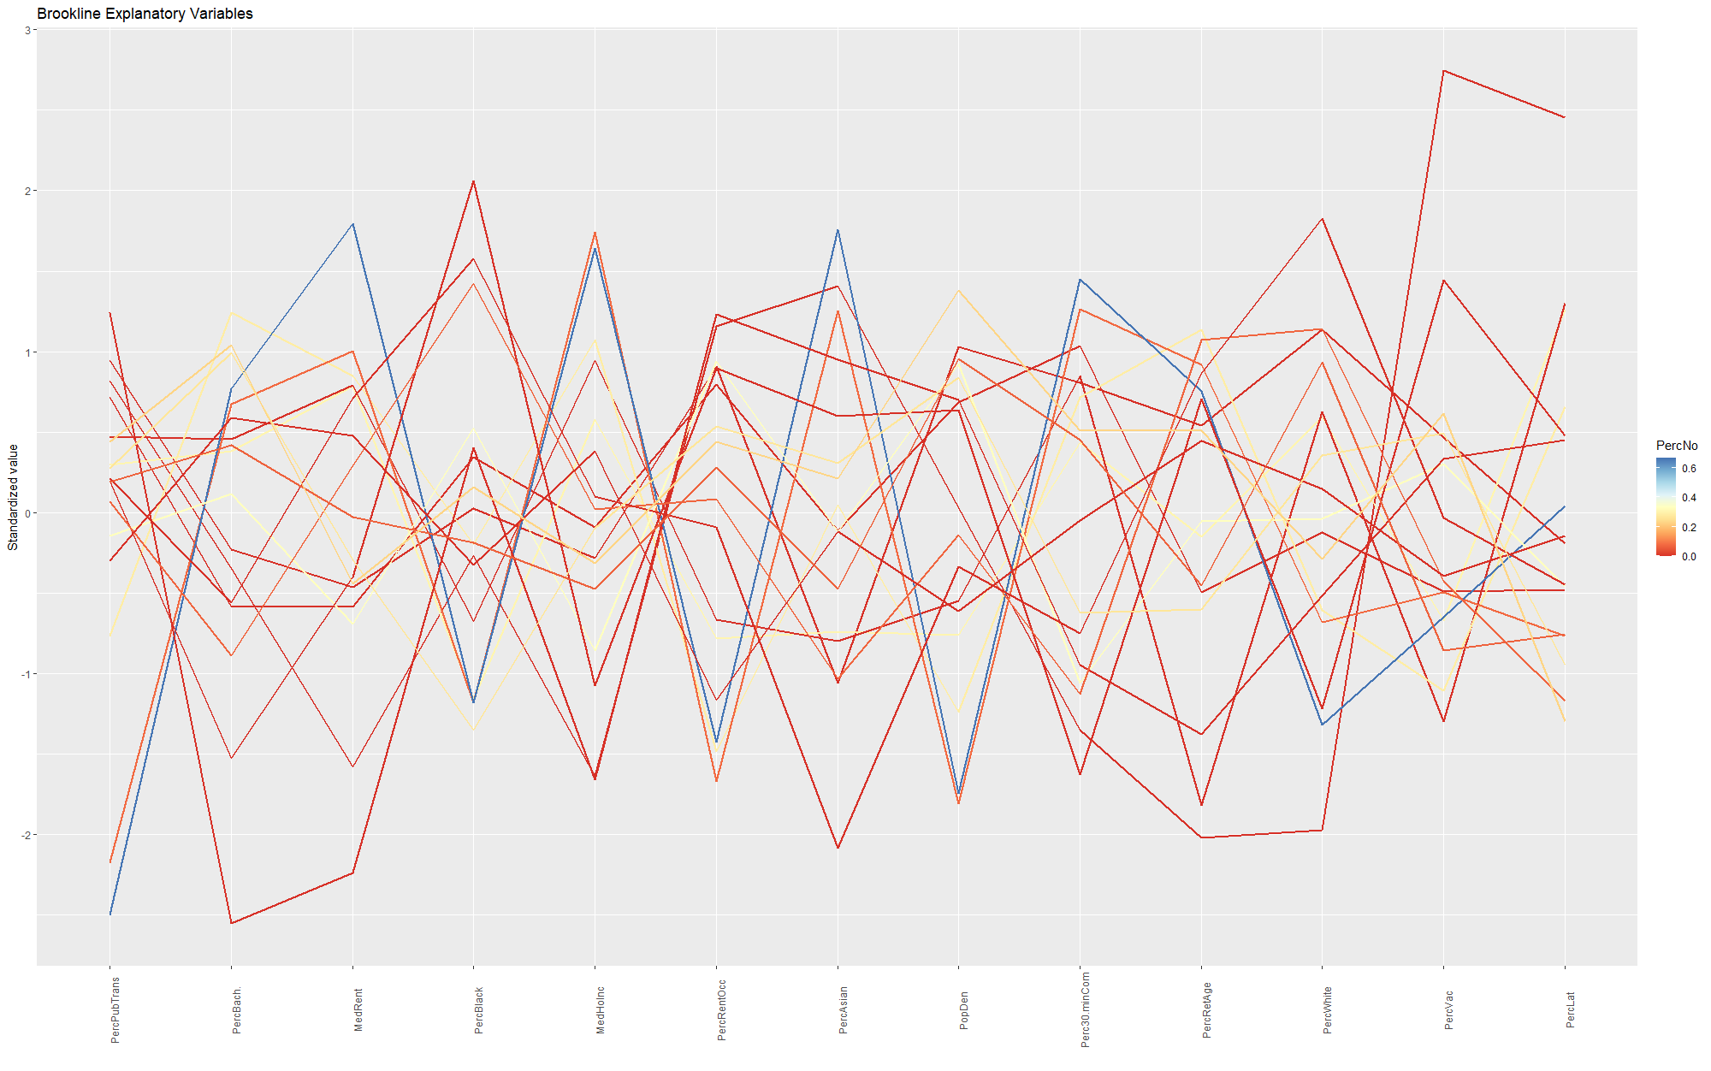
Figure 2. Brookline Parallel Coordinates Plot of Explanatory Variables
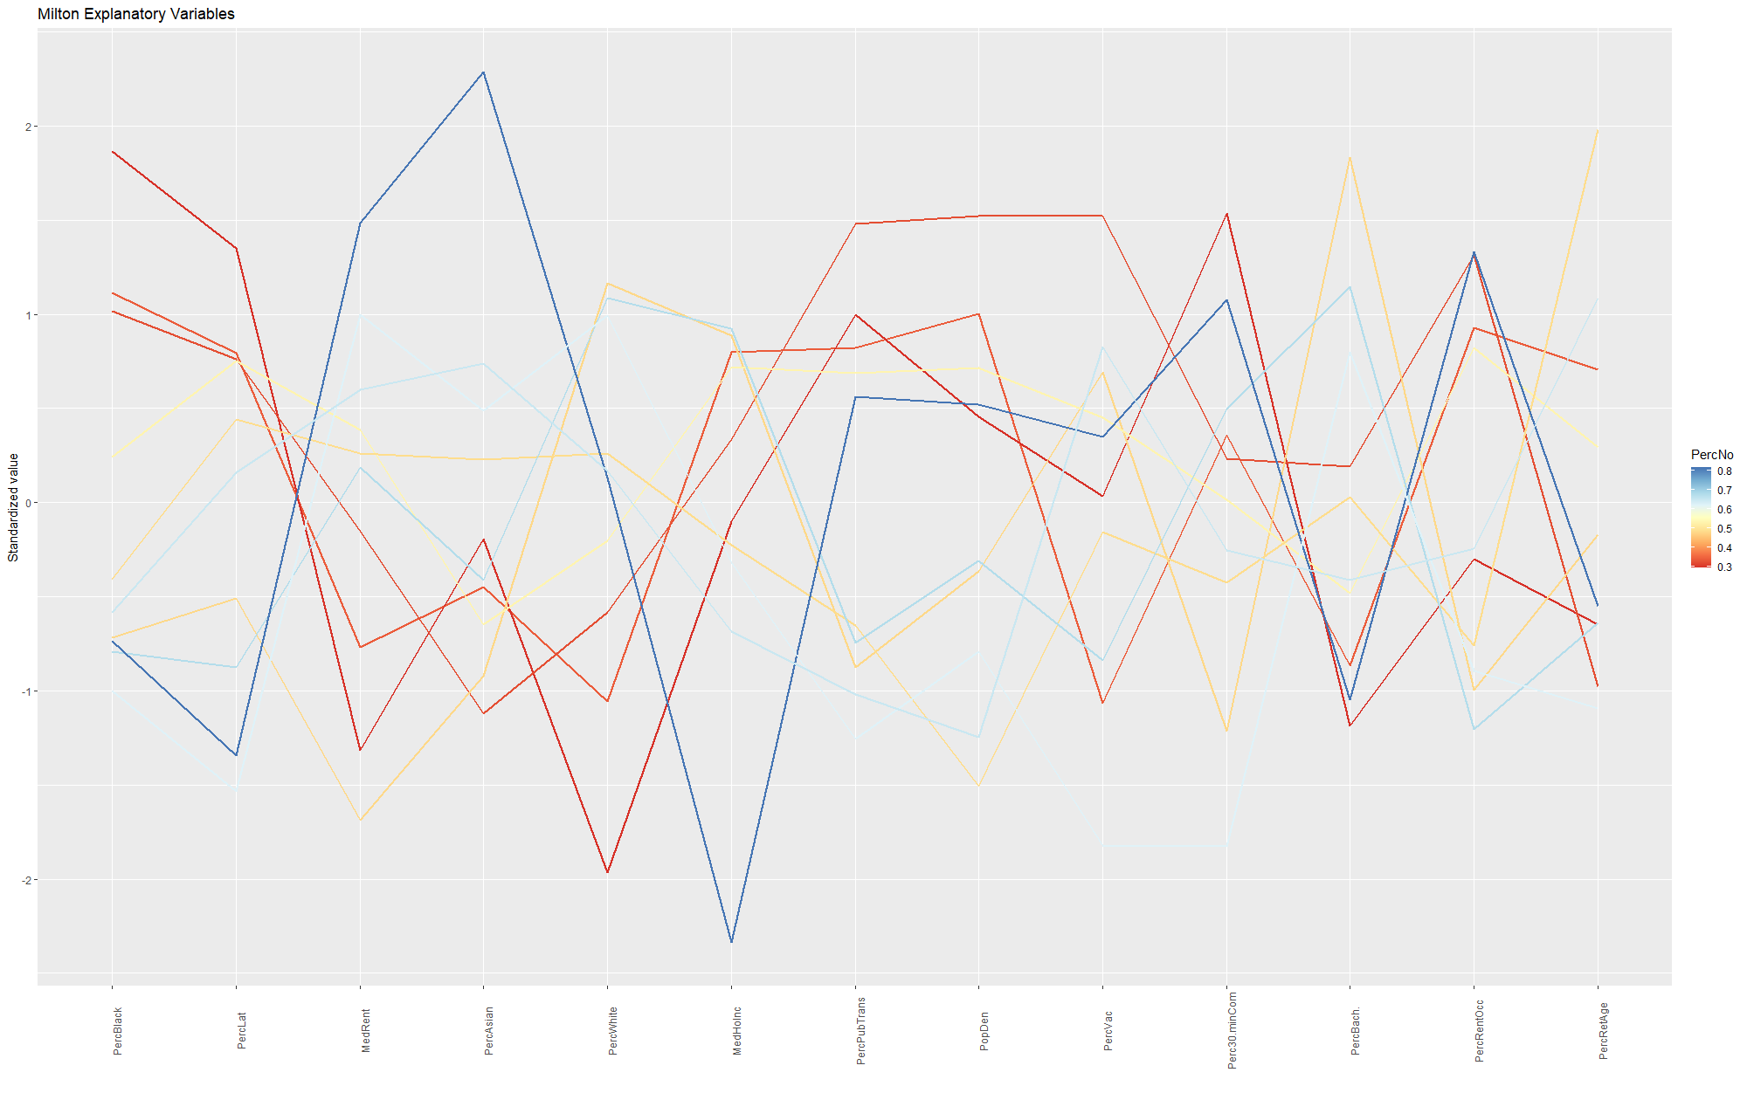
Figure 3. Milton Parallel Coordinates Plot of Explanatory Variables

I found that for Milton, five variables had a significant relationship with the percentage of votes in opposition: the four racial/ethnic variables and the median rent. Median rent, percent White, and percent Asian were strongly positively correlated with opposition, while percent Black and percent Latinx were strongly negatively correlated. For Brookline, only two variables were significant, and neither were variables that were significant for Milton. Instead, percent public transit users was negatively correlated, while percent with a bachelor’s degree or higher was positively correlated.
Many of the variables seemed to have intercorrelation (see figures 4 and 5).
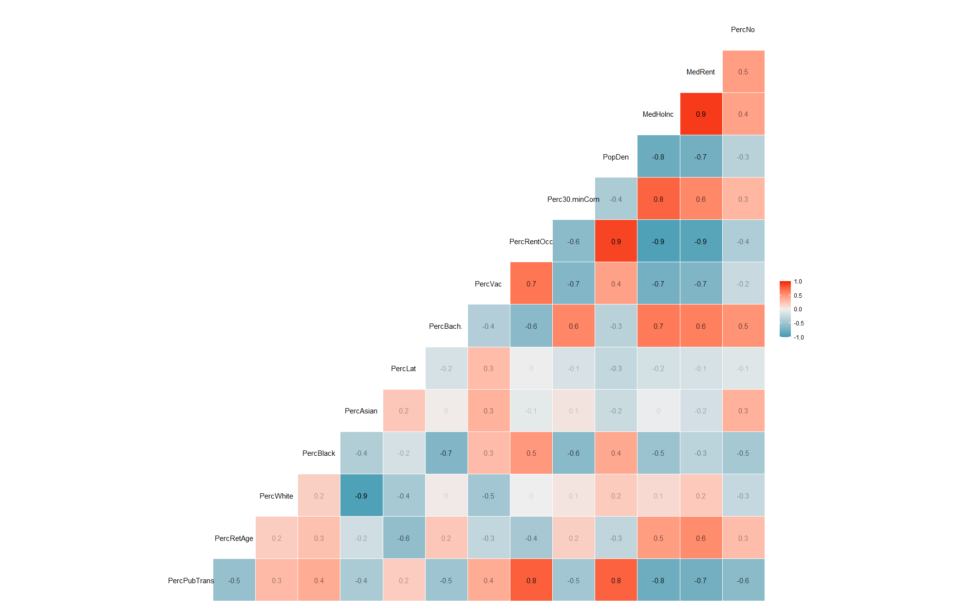
Figure 4. Brookline Correlation Plot
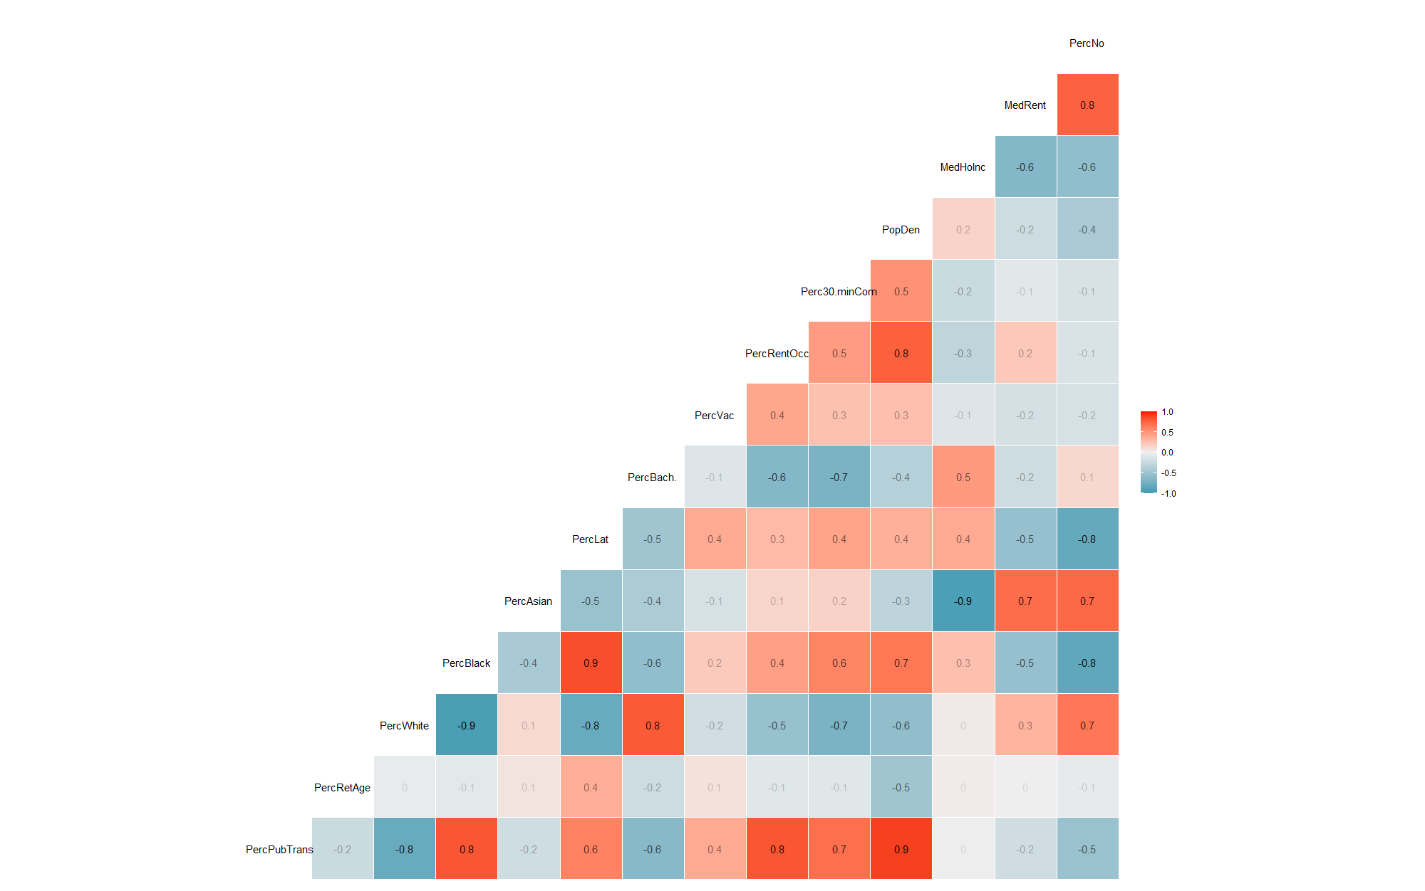
Figure 5. Milton Correlation Plot
While there was an insufficient number of data points to properly conduct a Bartlett test on the Milton data, Brookline had p-value of 0 on the Bartlett test, and both had Kaiser-Meyer-Olkin values greater than or equal to 0.5. Based on these findings, I opted to conduct a Principal Components Analysis (PCA). This decision also followed the methodology of Lincoln et al. in their analysis of the results of municipal elections [8].
I preformed the PCA using varimax rotation. Taking the components with eigenvalues greater than 1 generated four components for each town (see figures 6 and 7).
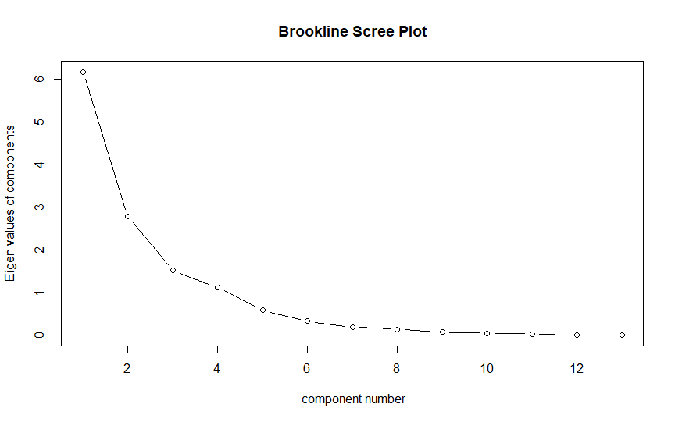
Figure. 6 Eigenvalues of Brookline Principle Components
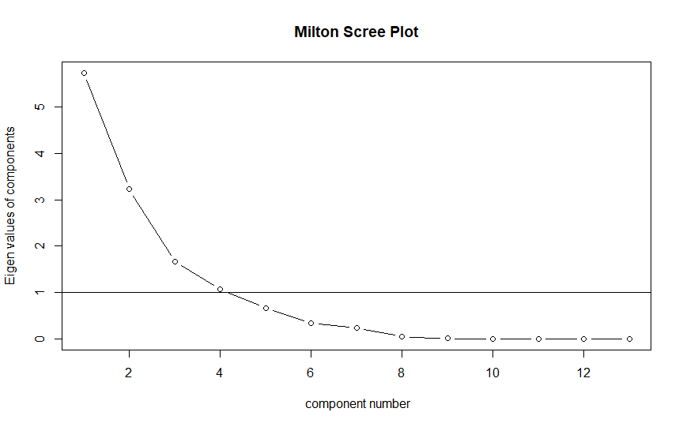
Figure. 7 Eigenvalues of Milton Principle Components

These components explained 89.9% of the variance in Milton and 89.3% of the variance in Brookline, respectively (see tables 1 and 2).
RC1 RC3 RC2 RC4
PercPubTrans 0.775 -0.270 0.395 -0.333
PercRetAge -0.538 -0.175 0.755
PercWhite 0.947 0.204
PercBlack 0.166 -0.873 0.226 0.257
PercAsian 0.157 -0.960
PercLat -0.103 -0.137 -0.228 -0.918
PercBach. -0.317 0.760 0.185
PercVac 0.532 -0.445 -0.525 -0.114
PercRentOcc 0.894 -0.389
Perc30.minCom -0.381 0.774
PopDen 0.932 -0.139 0.165 0.210
MedHoInc -0.815 0.515 0.115 0.154
MedRent -0.859 0.321 0.210 0.185

RC1 RC3 RC2 RC4
SS loadings 4.529 2.825 2.454 1.795
Proportion Var 0.348 0.217 0.189 0.138
Cumulative Var 0.348 0.566 0.754 0.893

Table 1. Brookline PCA Loadings

RC1 RC2 RC3 RC4
PercPubTrans 0.826 0.115 0.368 0.374
PercRetAge -0.926 0.105
PercWhite -0.968 -0.155
PercBlack 0.871 0.448
PercAsian -0.965 -0.107 -0.134
PercLat 0.703 0.538 -0.353 0.252
PercBach. -0.881 0.409 0.172
PercVac 0.116 0.932
PercRentOcc 0.613 -0.281 0.313 0.542
Perc30.minCom 0.793 -0.148 0.110 0.102
PopDen 0.599 0.194 0.671 0.327
MedHoInc -0.123 0.930
MedRent -0.180 -0.848

RC1 RC2 RC3 RC4
SS loadings 5.075 3.353 1.739 1.526
Proportion Var 0.390 0.258 0.134 0.117
Cumulative Var 0.390 0.648 0.782 0.899

Table 2. Milton PCA Loadings

Next, I created an Ordinary Least Squares (OLS) regression model for each town using its components as the inputs. I based this decision on the work of Iglesias-Pascual et al. who showed that OLS models provided greater interpretability of voting drivers than the Durbin spatial regression they were compared to [9]. The Milton OLS model described 85.3% of the variance in zoning opposition, but only one coefficient was significant. This component which had a p-value of less than 0.01, seemed to correspond to precincts with a low Asian population, high median income, and low median rent, and was moderately negatively associated with percentage of votes in opposition (accounting for about a 3.8% difference). The Brookline OLS model was much less effective, describing only 41.4% of the variance and having no significant component coefficients.
In the interest of seeing if I could develop a less town specific model that could perhaps be used to indicate which remaining towns would be most likely to oppose compliant zoning in the future, I pooled the data from Milton and Brookline and created a joint PCA-based OLS models. This model consisted of 3 components that described 78.2% of the variance (see table 3).
RC1 RC3 RC2
PercPubTrans 0.713 0.425 0.386
PercRetAge -0.449
PercWhite 0.154 -0.938
PercBlack -0.192 -0.775 0.548
PercAsian 0.300 0.770 0.151
PercLat 0.217 0.268 0.798
PercBach. 0.236 0.906
PercVac 0.761 0.206 0.251
PercRentOcc 0.822 0.480 0.193
Perc30.minCom -0.729 -0.366 0.147
PopDen 0.805 0.400
MedHoInc -0.935
MedRent 0.954

RC1 RC3 RC2
SS loadings 4.261 3.777 2.125
Proportion Var 0.328 0.291 0.163
Cumulative Var 0.328 0.618 0.782

Table 3. Joint PCA Loadings

It was able to account for 78.3% of the variance in Milton opposition and 49.1% of the variance in Brookline. The first coefficient was significant at the 0.05 level for Brookline, corresponding to a negatively associated component capturing young low-income renters of color, while the third, corresponding to highly educated, high-rent communities with a larger Asian population, was positively and significantly (p=0.01) associated with opposition in both towns (See figures 8-10).
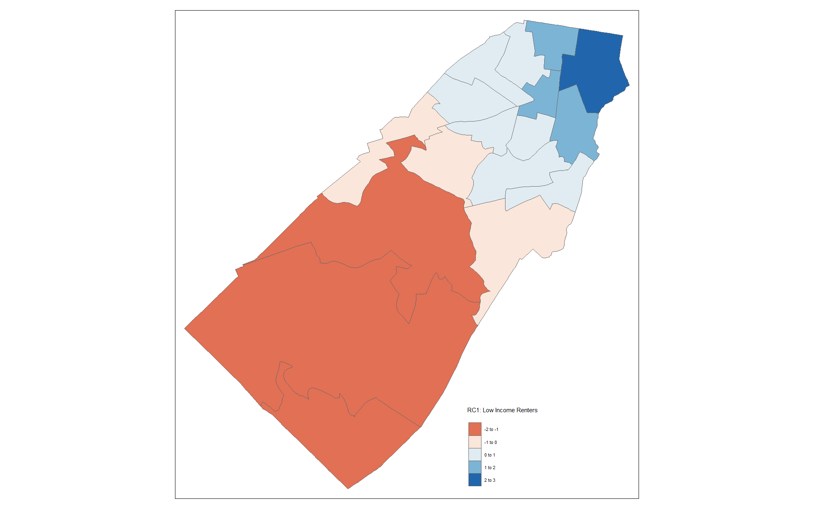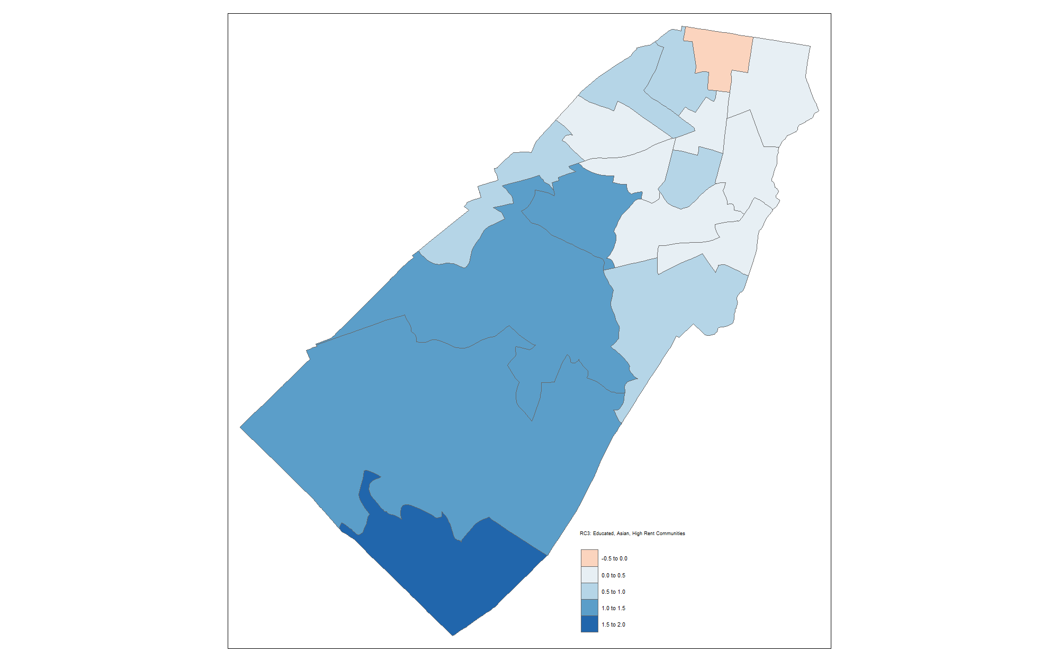
Figure 8-9. Brookline PC1 and PC3 by Precinct
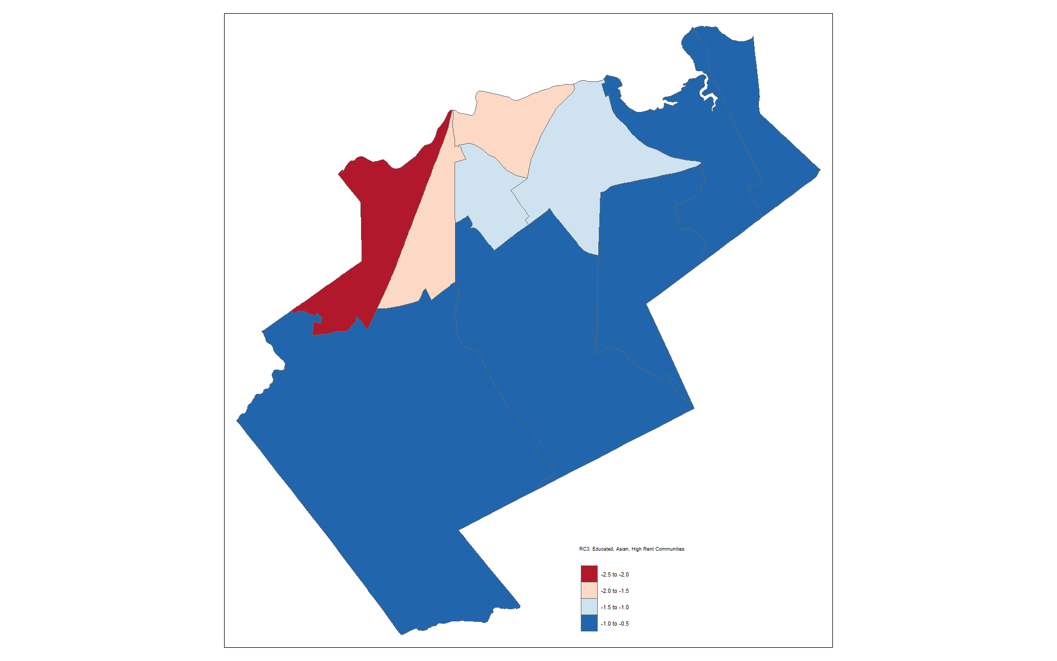
Figure 10. Milton PC3 by Precinct

Discussion:
Through my analysis, I found that the variables explaining opposition seemed to vary between Milton and Brookline, perhaps indicating that local factors drive voting outcomes more than generalizable demographic or spatial characteristics. The methods I applied also seemed more applicable to the Milton case than to Brookline. The Milton data seemed to have more spatial characteristics and was also better predicted by the models I produced. Pooling the data did marginally increase the OLS model’s accuracy for the Brookline data, but it still did not capture a useful amount of variance to make me feel comfortable applying such an approach to other towns.
Possibly this discrepancy was a result of there being fewer data points (Milton has only 10 precincts compared to 17 in Brookline), or that the election there was a ballot initiative with far greater participation than the Town Meeting vote that approved the zoning in Brookline. While the datasets appear comparable, perhaps the different methods of voting play a more significant role. Additionally, it may be that the variables, even though chosen based on the literature, were inappropriate or insufficient for the type of analysis I conducted. Perhaps additional variables would have better captured underlying distributions in the Brookline dataset. Finally, perhaps the way I aggregated the demographic data from census tracts to precincts introduced error that through off the analysis.

Conclusion and Future Work:
This study at least provides some initial evidence that the drivers of opposition to the MBTA Communities Act may vary from town to town. While I was unable to produce a compelling or generalizable explanation for voter opposition, there is still future work that could extend this project. In particular, I initially contemplated looking at current compliancy status in among all 177 effected communities. At the time, a full dataset did not exist, so I spent hours going through individual town websites in an attempt to compile such a dataset. Ultimately, my success rate at finding the current status was low enough that it didn’t make sense to continue along that avenue for this project. However, yesterday, May 7th, the Boston Globe published that exact dataset [10]. Using this new data it might now be possible to see if there is spatial autocorrelation or demographic similarities between towns which oppose the legislation, versus those already in compliance.

[1] “Multi-Family Zoning Requirement for MBTA Communities | Mass.gov.” Accessed: May 08, 2024. [Online]. Available: https://www.mass.gov/info-details/multi-family-zoning-requirement-for-mbta-communities
[2] D. M. Glick, K. L. Einstein, and M. Palmer, Eds., “Who Are the Neighborhood Defenders?,” in Neighborhood Defenders: Participatory Politics and America’s Housing Crisis, Cambridge: Cambridge University Press, 2019, pp. 95–114. doi: 10.1017/9781108769495.005.
[3] C. Atkinson-Palombo and M. J. Kuby, “The geography of advance transit-oriented development in metropolitan Phoenix, Arizona, 2000–2007,” Journal of Transport Geography, vol. 19, no. 2, pp. 189–199, Mar. 2011, doi: 10.1016/j.jtrangeo.2010.03.014.
[4] “MassGIS Data: Trains | Mass.gov.” Accessed: May 08, 2024. [Online]. Available: https://www.mass.gov/info-details/massgis-data-trains
[5] “MassGIS Data: 2020 U.S. Census | Mass.gov.” Accessed: May 08, 2024. [Online]. Available: https://www.mass.gov/info-details/massgis-data-2020-us-census
[6] “MassGIS Data: 2022 Wards and Precincts | Mass.gov.” Accessed: May 08, 2024. [Online]. Available: https://www.mass.gov/info-details/massgis-data-2022-wards-and-precincts
[7] G. Brown and H. Glanz, “Identifying potential NIMBY and YIMBY effects in general land use planning and zoning,” Applied Geography, vol. 99, pp. 1–11, Oct. 2018, doi: 10.1016/j.apgeog.2018.07.026.
[8] S. V. Lincoln, A. Piepe, and R. Prior, “An Application of Principal Components Analysis to Voting in Scottish Municipal Elections 1967-9,” Journal of the Royal Statistical Society. Series D (The Statistician), vol. 20, no. 4, pp. 73–88, 1971, doi: 10.2307/2986987.
[9] R. Iglesias-Pascual, F. Benassi, and V. Paloma, “A Spatial Approach to the Study of the Electoral Resurgence of the Extreme Right in Southern Spain,” Spatial Demography, vol. 10, no. 1, pp. 117–141, Apr. 2022, doi: 10.1007/s40980-022-00105-1.
[10] A. Brinker, K. An, and P. Christina, “Map: Nearly 200 towns must rezone under the MBTA Communities law. Has your town complied? - The Boston Globe,” The Boston Globe, May 07, 2024. Accessed: May 08, 2024. [Online]. Available: https://www.bostonglobe.com/2024/05/07/business/boston-housing-mbta-communities-law-towns/

